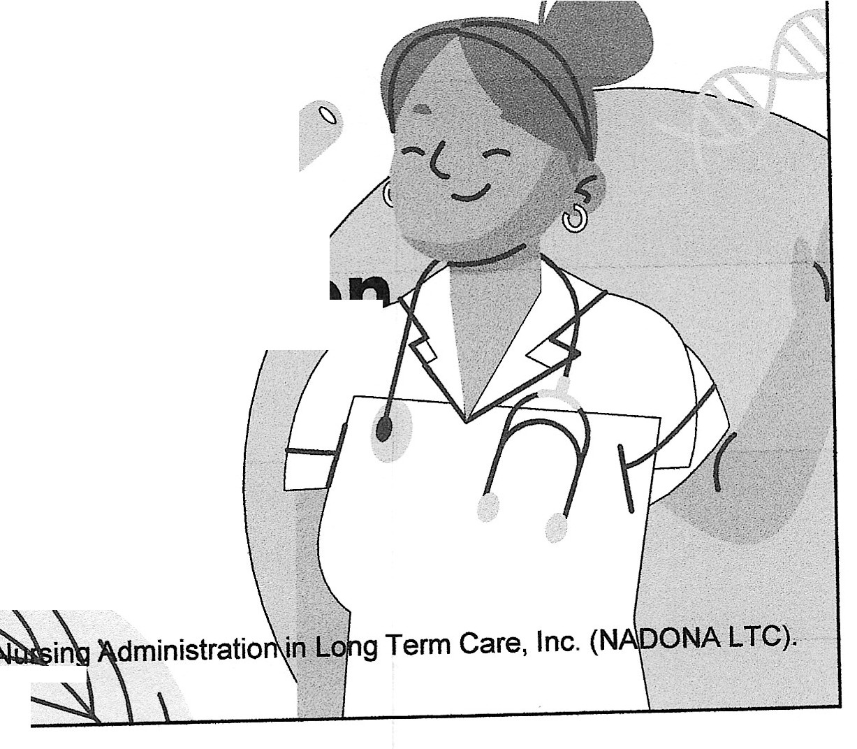
The Nurse Leader
Leadership /
Supervision/Delegat·o
Cindy Fronning RN-BC, CDONA, FACONDA, RAC-CT
IP-BC, AS-BC. CALN, QAPI-BC
.o
Director of Education
NADONA
© 2024 National Association of Directors DT"N,l,m.
All rights reserved.
1

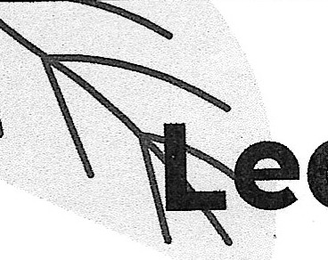
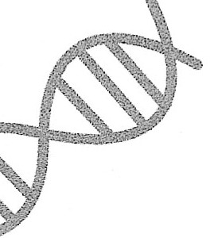
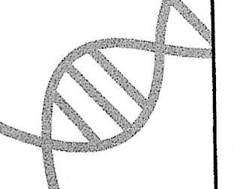
arning Outc e
As a result of this activity, learners will:
- be able to correctly identify the actions required to be an effective leader/manager.

- At the conclusion of this educational activity,
participants will self -report an intent to change their practice by applying evidence - based delegation methods within the nursing scope of practice
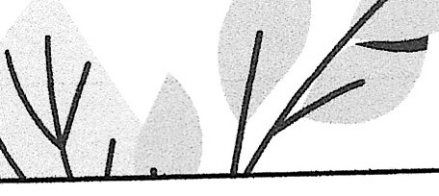
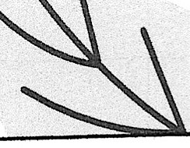
© NADONA 2024

2

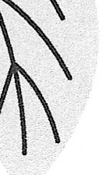
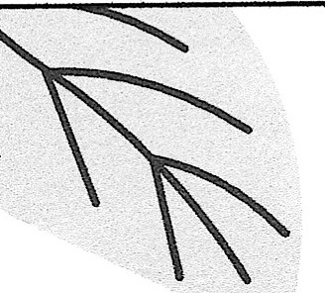
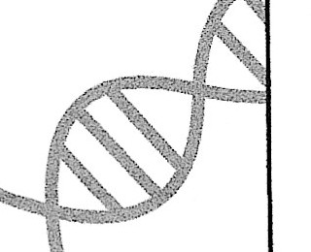
The participant will be able to:
the
. L•
u
e
!.Discuss the qualities of a nurse leader
- Explain the difference between Supervision/management and leadership
- Identify the differences in the Nurse Practice Act between RN and LPN
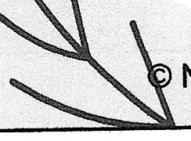
- De.scribe how empowerment can imP.act g Department
5 rights of delegation N DONA2024
3

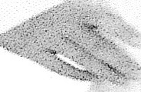
c:al
i11g
11ll I- ; e
leacle,-<.. »...,..
© NADONA 2024
4

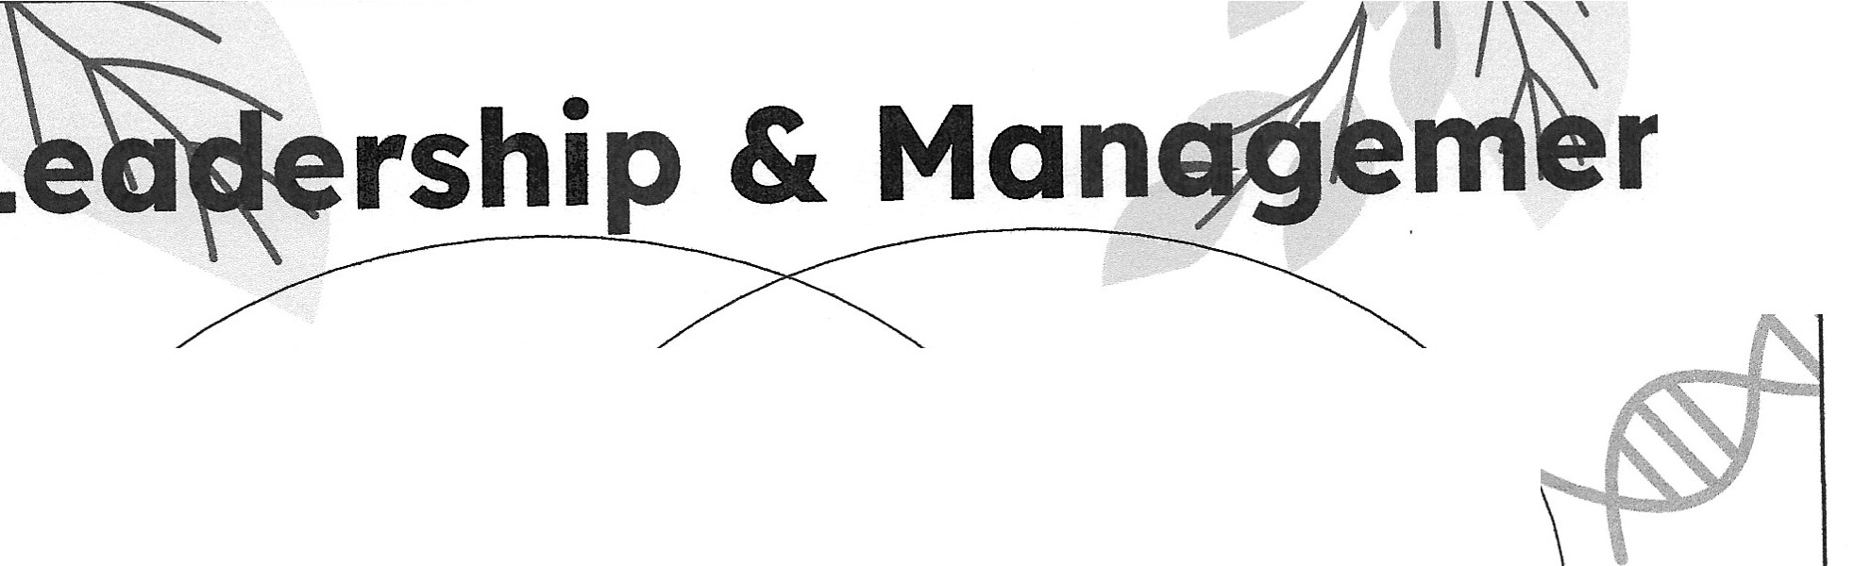
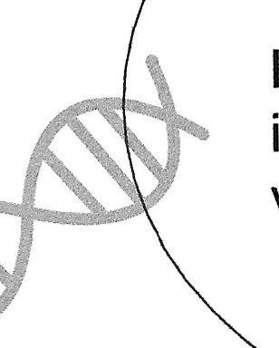
nt

Leadership
Instilling an inspiring vision

Supervision Ensuring important things getdone

Management
Instilling good operational processes

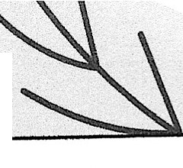

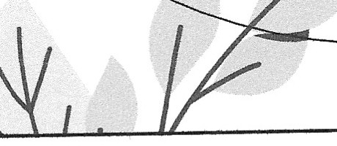
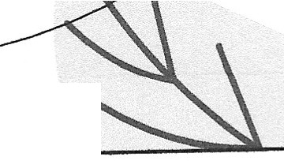
5

© NADONA 2024

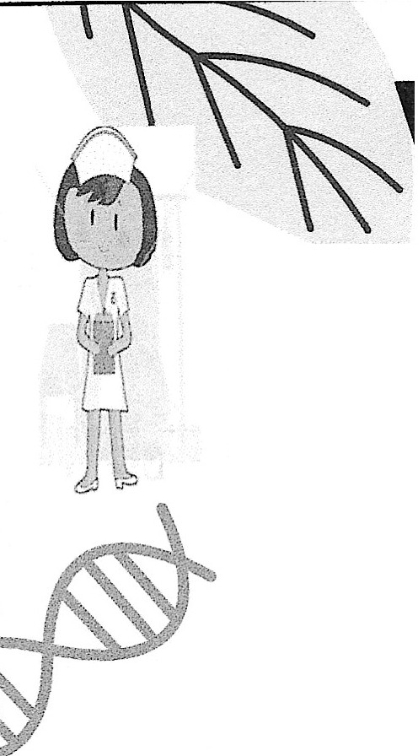
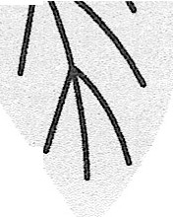
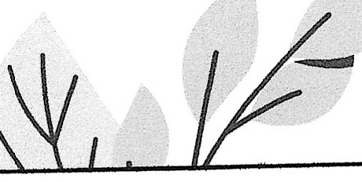
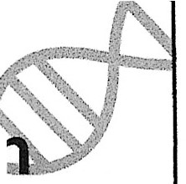
What is a Gr
Leader?
"A leader is one who knows the way, . goes the way, and shows the way." Jo....•,...L•
C. Maxwell
Are you a difference maker between©
NADONA 2024
success and failure?
© NADONA 2024
6

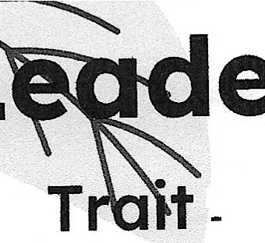
_ er Qualities "' s
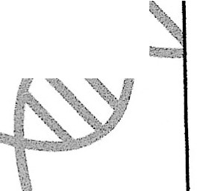
t - a distinguishing quality or characteristic, typically one belonging to a person.
QuaIity -a distinctive attribute or characteristic possessed by someone or something.

What does a great leader look like?

Has a futuristic vision
- Turns ideas into real world success stories

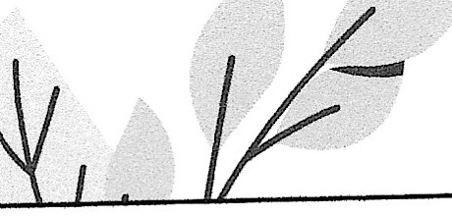
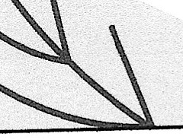
© NADONA 2024
7

Qualities
- Honesty / integrity/ Character - "The supreme quality of leadership is unquestionably integrity." Dwight D Eisenhower
- Confidence / Competence - should at least reflect the degree of confidence required to ensure that your followers trust you as a leader
- Inspires others - "If your actions inspire others to dream more, learn more, do more and become more, you are a leader." John Quincy Adams
- Commitment / Passion / Enthusiasm- getting your hands dirty will also help you to gain the respect of your subordinates and infuse new energy in your team members, which helps them to perform better.
- Good Communicator - Words have the power to motivate people and make them do the unthinkable. © NADONA 2024
8

Qualities cont.
- Decision Making Capabilities - A leader should think long and hard before taking a decision but once the decision is taken, stand by it.
- Accountability/ Loyalty - "A good leader takes little more than his share of the blame and little less than his share of the credit." Arnold H Glasow
- Delegation/Empowerment /Team Builder- empowering your followers and delegating tasks to them will develop a trust factor and leave time for more important matters
- Creativity / Innovation / Vision - Innovation distinguishes between a leader and a follower."
- Empathy - Understanding the problems of your followers and feeling their pain is the first step to become an effective leader.
- Charisma - The best leaders are well-spoken, approachable and friendly. They show sincere care for others. © NAooNA 2024
9

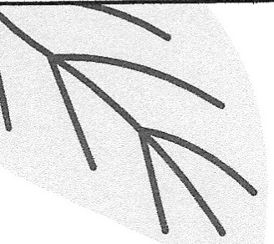
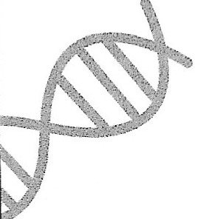
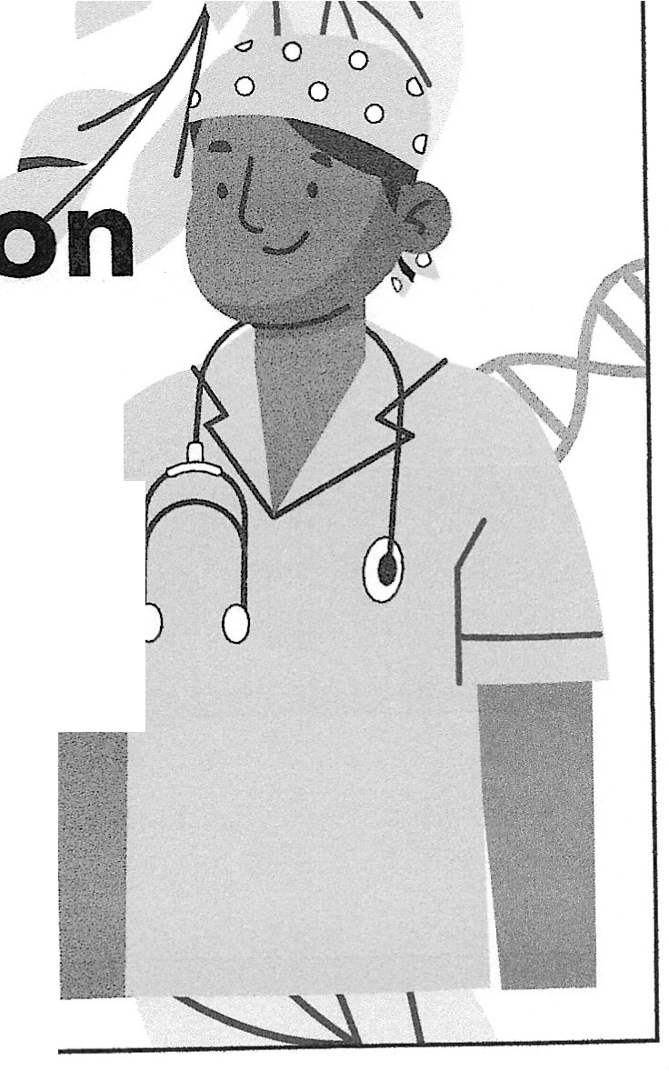
Self
Introspect1•
- Which of these traits or qualities do you see in YOU?
d.
- Which ones do you need to acquire?
Which ones do you need to hone?
- Do you have any that you need to
tone down or eliminate? -.

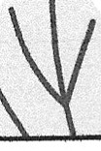
© NADONA 2024

10

/i; .rl', 1. lead by example with an overriding guiding vision or
Ir:Great Leaders:
What Great Leaders Do

.•
- ' "
.ft
· ,_
purpose.
- know how to be themselves and are proud of who they are
- have the ability to inspire confidence in others
- rarely question themselves
- know when to take advice
- possess the foresight to move ahead, even in the most questionable times
- love what they do and communicate their passion to others.
- learn to lead by following
- never quit
10. are never self-serving © NAooNA 2024
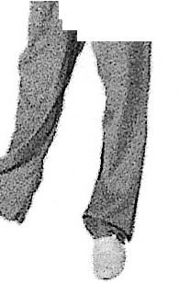
11

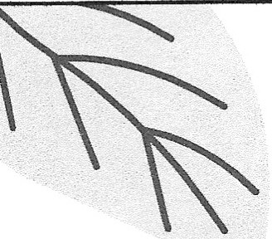
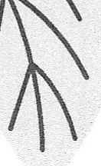
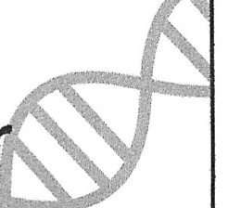
What is
Managemen
Management is the act or skill of controlling and making decisions about a business, department, o
other enterprise. ,
..,......,_. A manager is responsible for efficiently accomplishing the goals of the organization through others
- Name some Managers in the NH
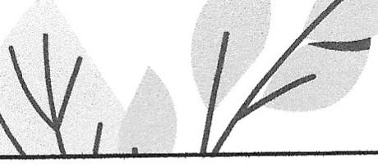
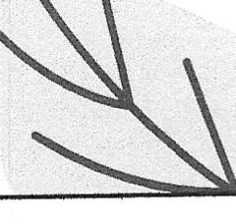
- What do you expect of a Nurse Manager

© NADONA 2024

12

What is Supervision?
Definition of supervision.
- the actiory, process, or occupation
of supervising especial/ya critical watching and directing (as of activities or a course of action)

Would a nurse leader be in one or more of these roles?

© NADONA 2024
13

4
Who is the Supervisor?
© NADONA 2024
14

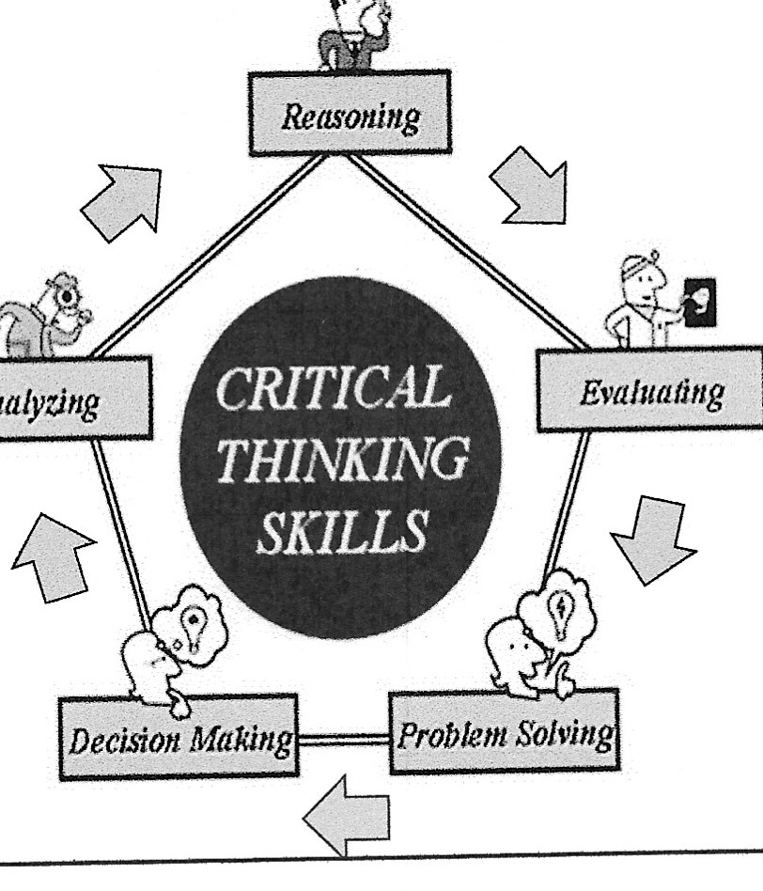
Critical Thinking
- Disciplined thinking that is clear, rational, open-minded, and informed by evidence
- Guided by professional standards and codes of ethics, not hunches or op1n1ons

© NADONA 2024
15

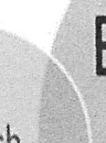
available research and evidence to clinical practice
- Use evidence-based articles and information for policies, procedures, and nursing practice
- Example: AHRQ evidence-based program, Team Strategies and Tools to Enhance Performance and Patient Safety (TeamSTEPPPS) has proven effectiveness of reducing patient safety issues
Evidence Based Practice (EBP)
- Applying the most current, best
Clinical
expertise
Research
Evidence
Based Practice
Patient preferences
Resources
http://www.ahrq.gov/professionals/education/curriculum­ tools/teamsteppps/longtermcare/index.html
© NADONA 2024
16

The History Of EBP
- 1800's - Florence Nightingale : Regarding the Life & Passion of Miss Florence Nightingale (https://www.youtube.com/watch?v=Z58-5iuxCFQ)
- 1972 - Archie Cochrane
- 1996 - David Sackett
This Photo by Unknown Author is licensed under CC BY-NC-ND
© NADONA 2024
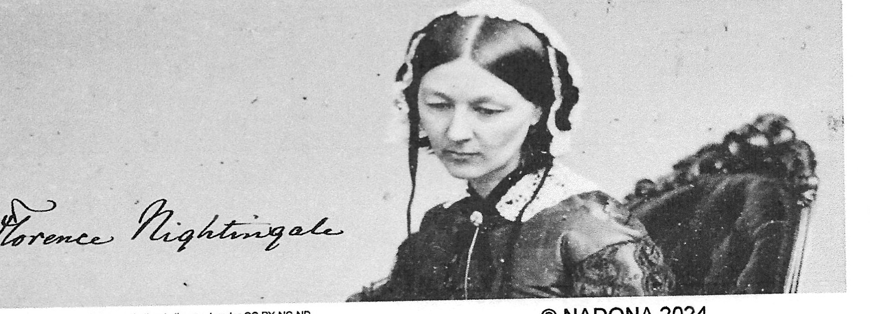
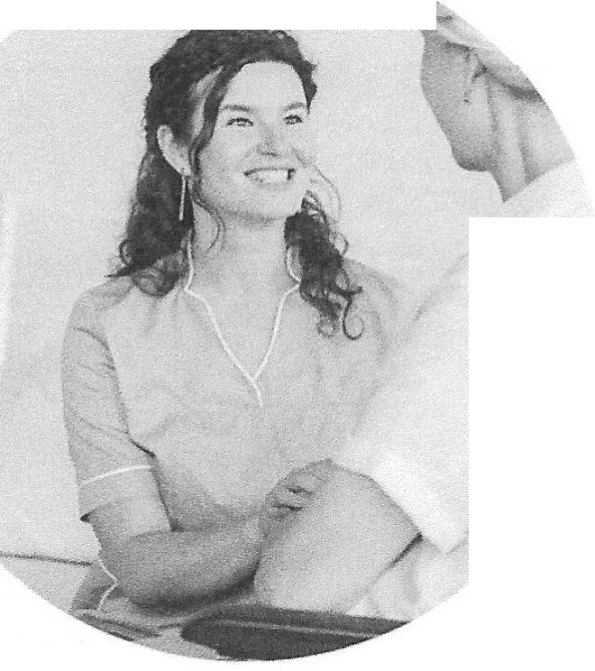
17

'
Evidence Based Practice
What Is EBP In Nursing?
An integration of research evidence, clinical expertise and a patient's preferences.
A problem-solving approach to clinical practice which encourages nurses to provide individualized patient care.
How Is EBP Incorporated In Nursing? Helps develop an effective course for delivery of care.
5 Steps
- Form a clinical question to identify a problem.
- Gather the best evidence.
- Analyze the evidence.
- Apply the evidence to clinical practice
- Assess the result. (Also known as ????)
© NADONA 2024
18

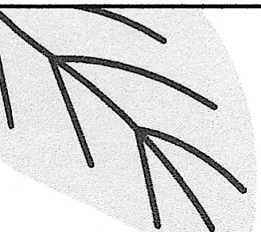
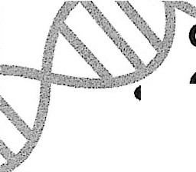
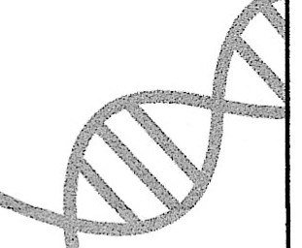
EBP cont. A 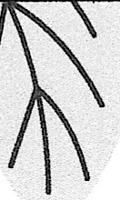

Kinds of Research Used In EBP (Most credible to less credible)
- Randomized controlled trials.
,.Pii."'-'""1.t Evidence gathered from cohort, case-control analysis or observational studies.
- Opinions from clinical experts that are supported by experiences, studies or reports from committees.
- Personal experience.
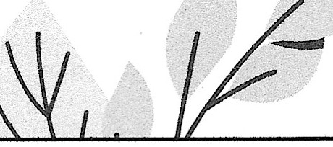
© NADONA 2024 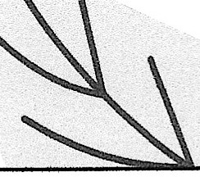
19

EBP cont.
- Benefits of EBP
  - Provides nurses with the scientific research to make well-founded decisions
  - Nurses can stay updated about new medical protocols for patient care
  - Searching for documented interventions can increase their patients' chances for recovery.
  - Helps nurses understand the risks or effectiveness of a diagnostic test or treatments
  - Enables nurses to include patients and thus allows patients to have a proactive role in their own heaIthcare © NAooNA 2024
20

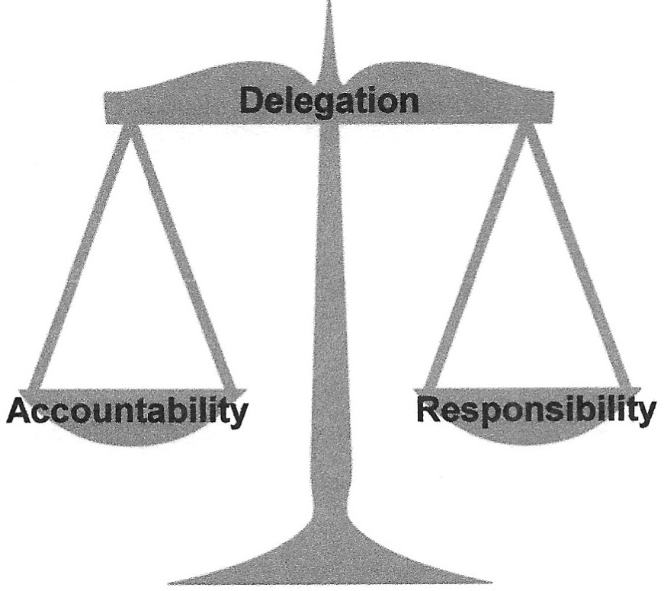
Accountability and Responsibility
- Accountability- the state of being accountable, liable or answerable
o Accountability means you are answerable to an authority for the activity, regardless of whether you perform it or delegate it
  - Responsibility - duty to satisfactorily complete a task assigned by someone that must be fulfilled and which has a consequence for failure to do so
    - RESPONSIBILITY CAN BE DELEGATED
    - ACCOUNTABILITY cannot
© NADONA 2024
21

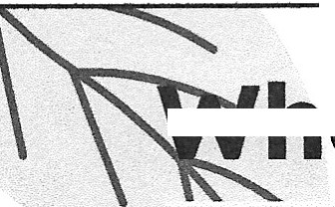
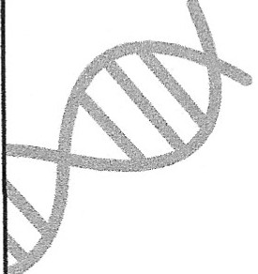
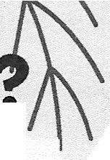
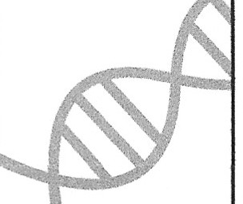
---.....at Can They Rea!!.._ o.
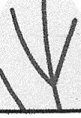
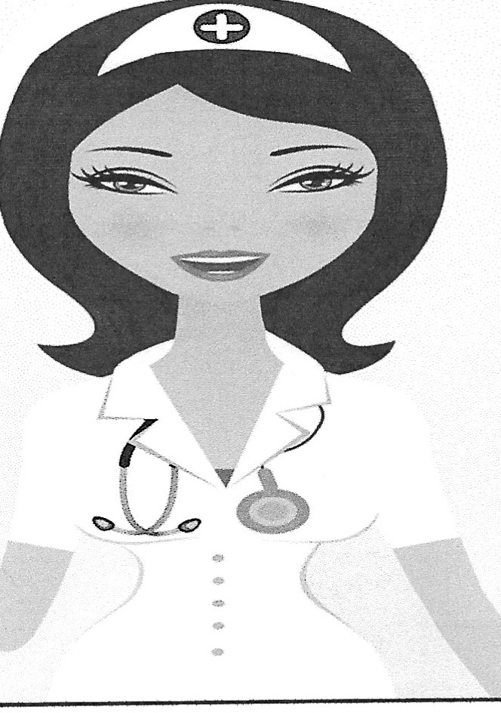
22

When choosing
to delegate...
,
□o==a
P.i,"
-
'\
'"-'A
=
- Ask:
  - Is it critical that you complete the task?
  - Is there someone who has the expertise to complete the task?
  - Will the task develop another person's skills and confidence?
  - Can the person selected work independently?
  - Do you have time available to provide adequate training and to answer questions, check progress, and contribute if necessary?
  - Does the person have enough time to take on the work?
© NADONA 2024
YOU I-IAVE TO DELEC":,ATE
SOMEsIponsibilitYI
23

Delegation - unleashing the power of others
- Delegation transfers responsibility for a procedure or task without transferring accountability
- To delegate, the nurse must know the person's scope of practice, qualifications, and competence
- Reasons leaders fail to delegate when they should:
  - Fear the task will not be done well, or will not be done at all
  - Fear of giving up control
  - Time constraints for teaching the other person how to do the job
  - Concerns about burdening a team member with more work

© NADONA 2024
24

National Council of State Boards of
·····-Nu-rsing- Delegation-is -appropriate
when & what...
- The nurse is certain that delegating the activity is not against the law
- The person to whom the task is delegated has been taught to perform the procedure, and can demonstrate the procedure correctly if necessary (Proof in file)
- The resident is stable and frequent, repeated assessments are not necessary
- The resident's response to the activity is reasonably predictable
© NADONA 2024
25

THE FIVE RIGHTS OF DELEGATION
- RIGHT TASK
One that is delegable for a specific client.
- RIGHT CIRCUMSTANCES
Appropriate patient setting, available resources, and other relevant factors considered.
- RIGHT PERSON
Right person is delegating the right task(s) to the right person to be performed on the right person.
- RIGHT DIRECTION/COMMUNICATION
Clear, concise description of the task, including its objective, limits and expectations.
- RIGHT SUPERVISION
Appropriate monitoring, evaluation, intervention, as needed, and feedback.
© NADONA 2024
26

Tips for Delegation Success

- Give specific details
- Be selective about what and to whom you delegate
- Delegate small tasks first
- Be a resource without taking over the project
- Give realistic timelines for completion
- Provide necessary tools and resources
- Reward and recognize success in a timely manner
- Clarify your expectations as often as needed
© NADONA 2024
27

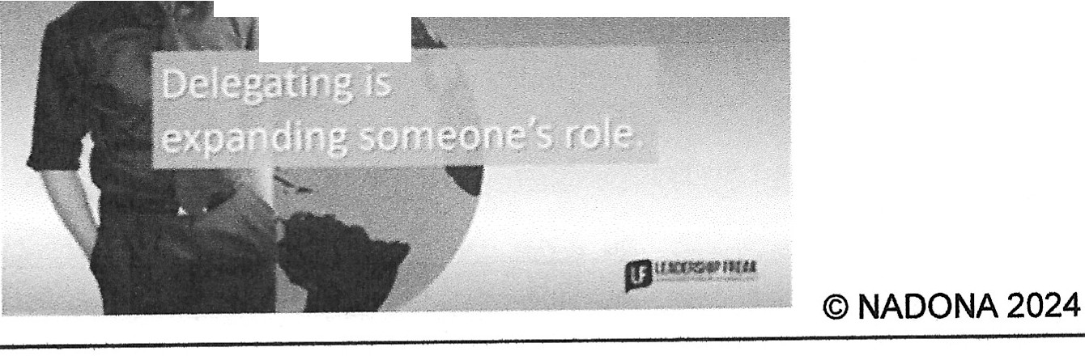
Benefits of Delegation
- Frees up time for you to focus on other job duties
- Builds staff self-esteem and grows new leaders
- Provides a clear message to staff that teamwork is valued
- Displays to the organization the level of trust within the
department with you as the leader
---.-=.--.,,.._..,-------------.-..
28

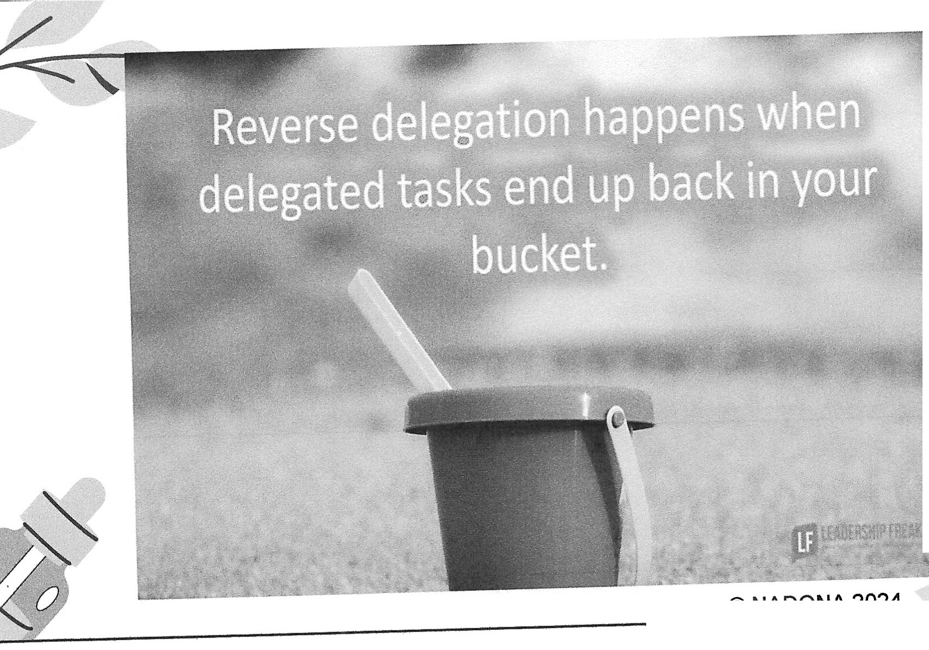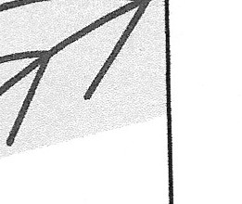

--- '\
© NADONA 2024 ,
29

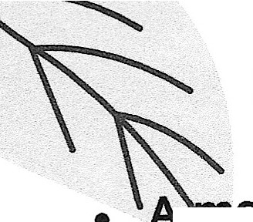
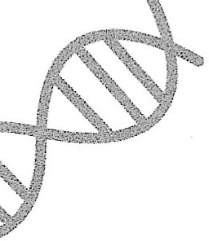
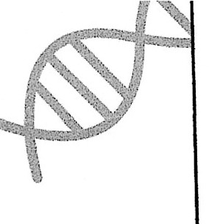
Empowerme.jtt 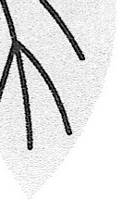
- A anagement practice of sharing mformation. rewards. and power with employees so that they can take initiative and make decisions to solve problems and improve service and performance.

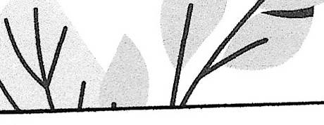
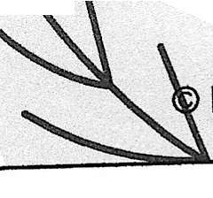
- Empowerment is based on the idea that giving employees skills. resources. authority. opportunity, motivation. as well holding them responsible and accountable for outcomes of their actions. will contribute to their competence and s tisfaction.
  - http://www.businessdictionarycom/definition/empowennent.html N DONA2024

30

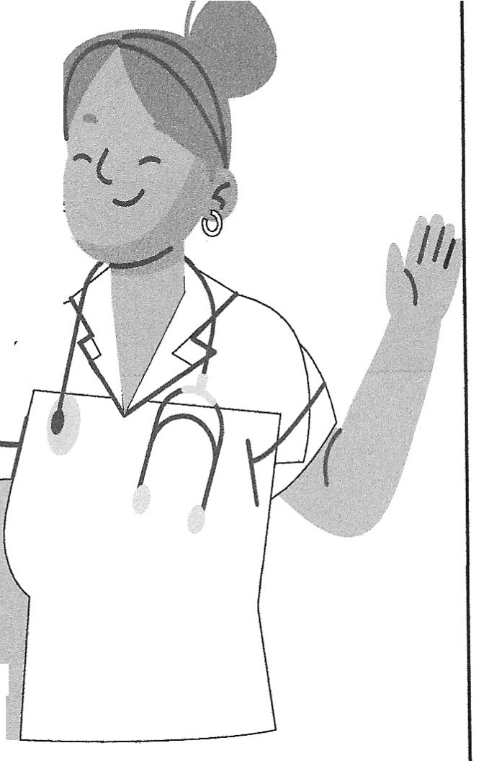
What Does Empowerment look like
in the Nursing Department ?
- Does the DON have to meet with all employees regarding every situation?
- Does the DON have to chair every committee and task force?
- What can the supervisor or nurse manager handle?
- What could the Floor nurse resolve?
- How can a CNA become empowered?
© NADONA 2024
31

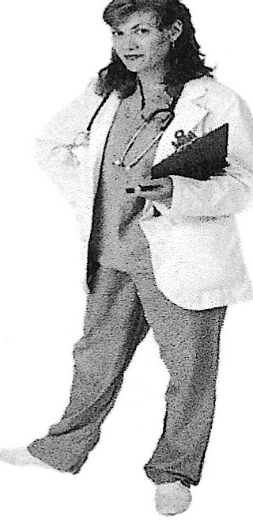

Empowerment also leads to:
New Leaders

© NADONA 2024
32

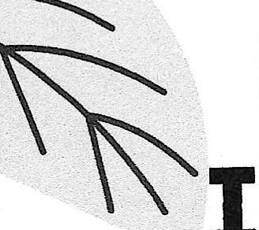
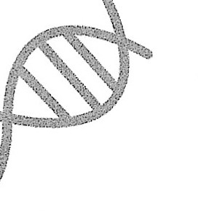
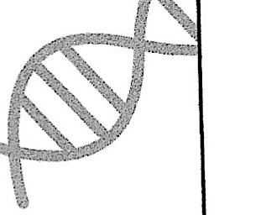
Empowerme Invokes Cha
-
- Changes in the DON's life

- Changes in buy in of the team

- Changes in retention & loyalty

- Changes in satisfaction surveys both resident & staff

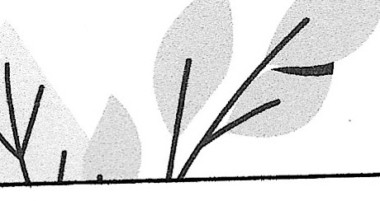
© NADONA 2024

33

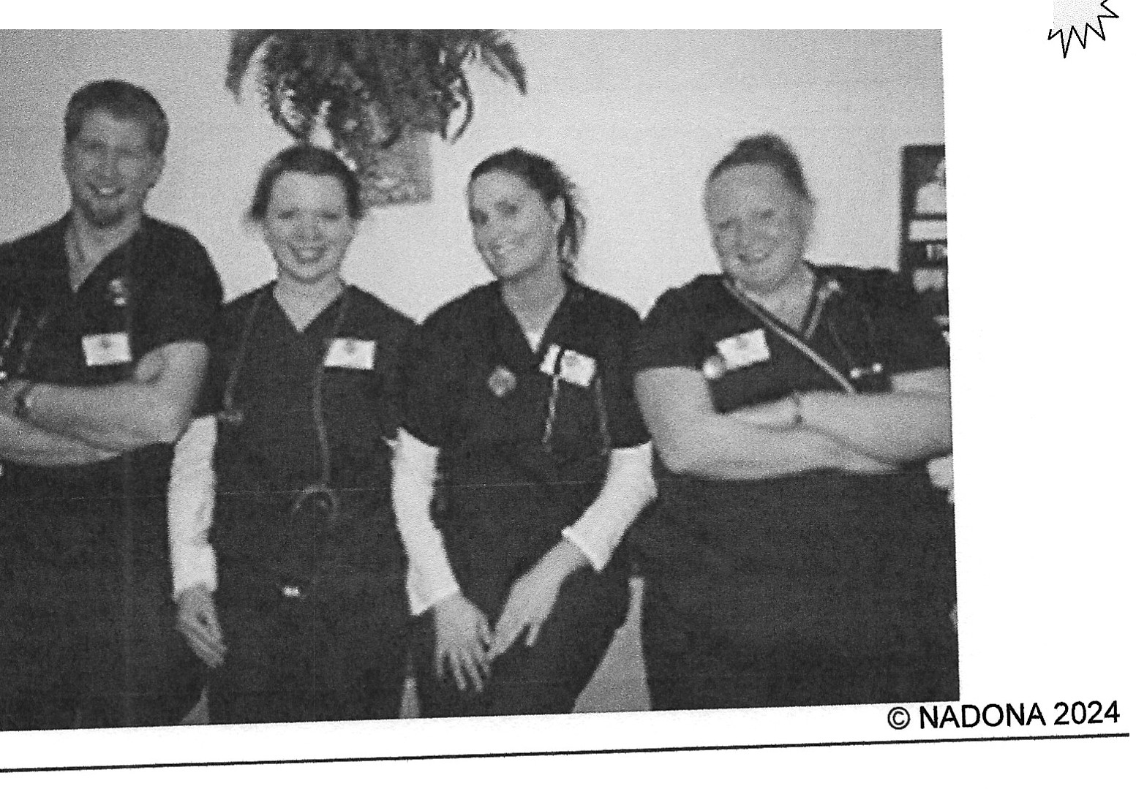
Who's in Your Facility or on Your Team?
34

Who is going to Take oQ?
9 Qualities that will assist Nursing Executives in fostering new leadership
1. Emotional Intelligence (EI) defined as the ability to: Recognize, understand and manage our own emotions. Recognize, understand and influence the emotions of others.
Nurse leaders will need to:
Help new trainees to develop EI
This assists with the coping of stressors in routine situations where there needs to be a calm centered approach to prevent poor teamwork .

© NADONA 2024
35

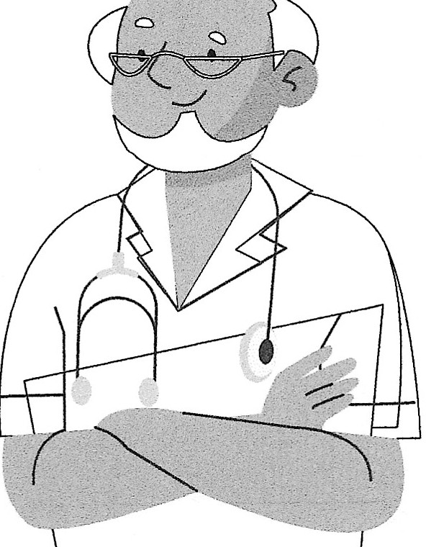
Who is Going to Take Over? cont.
2. Integrity is defined as the quality of being honest and having strong moral principles; moral uprightness.
Nurse executives must display their own integrity and role model for the nurses in making the correct choices during critical situations in resident treatment plans.
Provide training of ethical practices that allows new nurse leaders to make effective and safe decisions.
© NADONA 2024
36

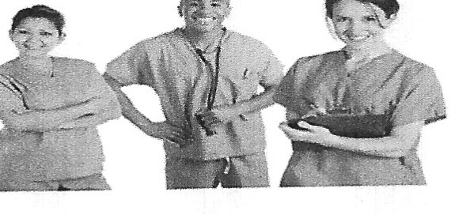
Who is Going to Take Over? cont.
- Critical Thinking
Teach the inexperienced nurses in the practice of making decisions based on many factors.

- Dedication to Excellence
Nurse leaders need to deliver excellent service to teach by example. Often more frequent performance assessments are used to talk about this service component.

© NADONA 2024
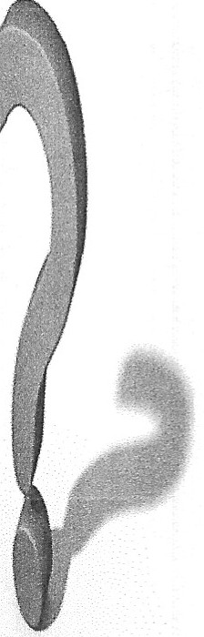
37

Who is Going to Take Over? cont.
5. Communication Skills - Need for collaboration is great amongst the interdisciplinary team.
1
Training in this area can be accomplished by having these nurses round with the DON and attend standup meetings
6. Professional Socialization
By observing the nurse -resident interaction the nurse executive can identify opportunities that can be discussed with
the newer nurse
© NADONA 2024
38

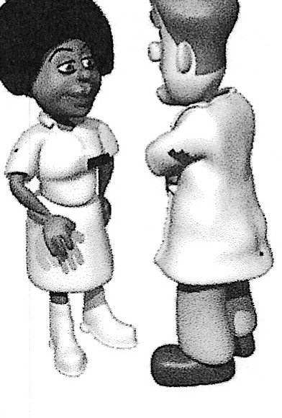

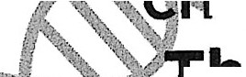
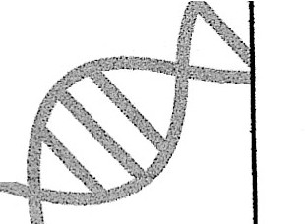
is Going to Take 0 co

--........

7. Respect
"Nurse leaders are passionate, dynamic influencers who inspire change in others and,•
. he process, win the respect and trust of their
,,. i..harges"
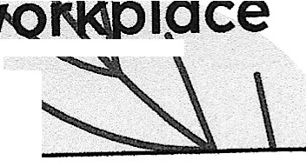
, -, his is accomplished by teaching two-way communication, paraphrasing and restating both the feeIings and words.
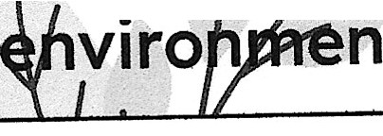
his pr m,,-res a positive, productive ,_,,
nt. © NADONA 2024

39

Who is Going to Take Over? cont.
8. Mentorship
Become familiar with what motivates the new nurse
Provide guidance towards understanding their role as not only a care giver but a nurse leader
Establish an environment of continual learning
Continue to identify learning opportunities but allow some
autonomy
© NADONA 2024
40

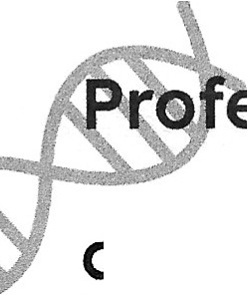
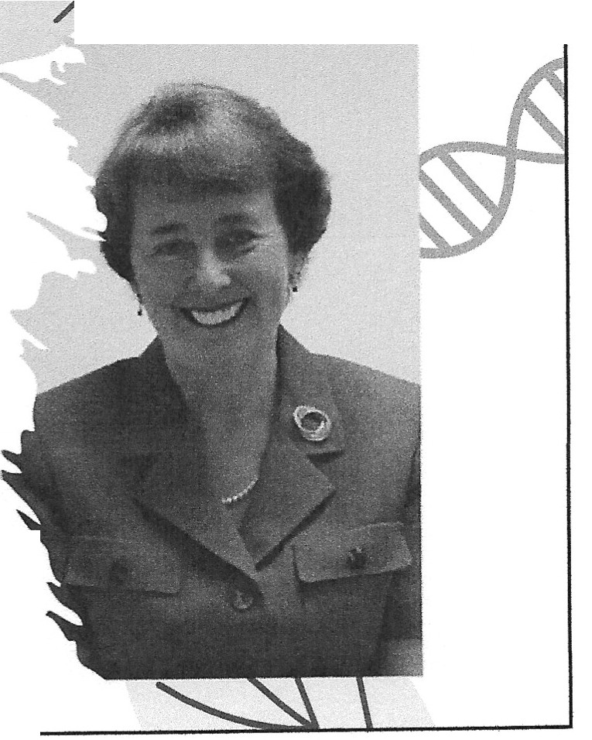
o is Going to Take ? c t.

9. Professionalism
Defined as the competence or skill expected of a professional.
N_ursing: Dynamic ess1on
Requires competent, confident leadership
Are you instilling in your nur ing staff he need for
. .-
pr SSIO m?
© NADONA 2024
41

'''
Succession of the DON V
An old adage is,
"If your unft or department can run without you,
you have done your job."
. This is true, so develop your succession plan early. You can't do it all alone.
. Jdenti(y your informal and formal leaders and invest 1n them.
. Take them to meetings with you· have them provide P.resentations to the staff and senior­ level leaclers.
. Find opP.or.tunitie to highlight their strengths and m1n1m1ze their weal<nesses.
. Train them to be the next leaders.
https://www.americqnnursetoday.com/nine-principles-of-successful-nursing-leadership/ © NADONA 2024
42

Summary
- Determine the qualities of leadership you are looking for
- Observe and conclude which staff demonstrate those
· qualities
- Hire and onboard staff with those qualities
- Mentor and train staff
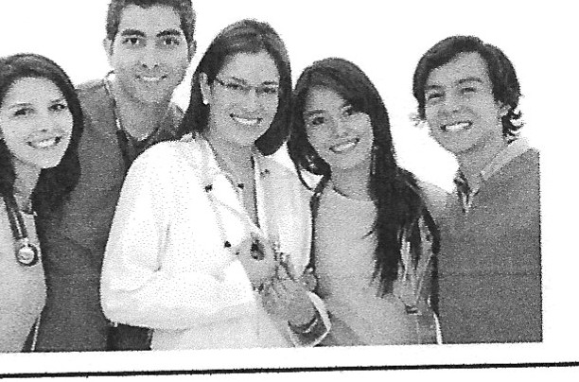
- Continue to allow staff to see you as the ultimate professional by demonstrating all the traits you are training
"Leadership and learning are indispensable to each other."
- U.S. President John F. Kennedy

© NADONA 2024
43

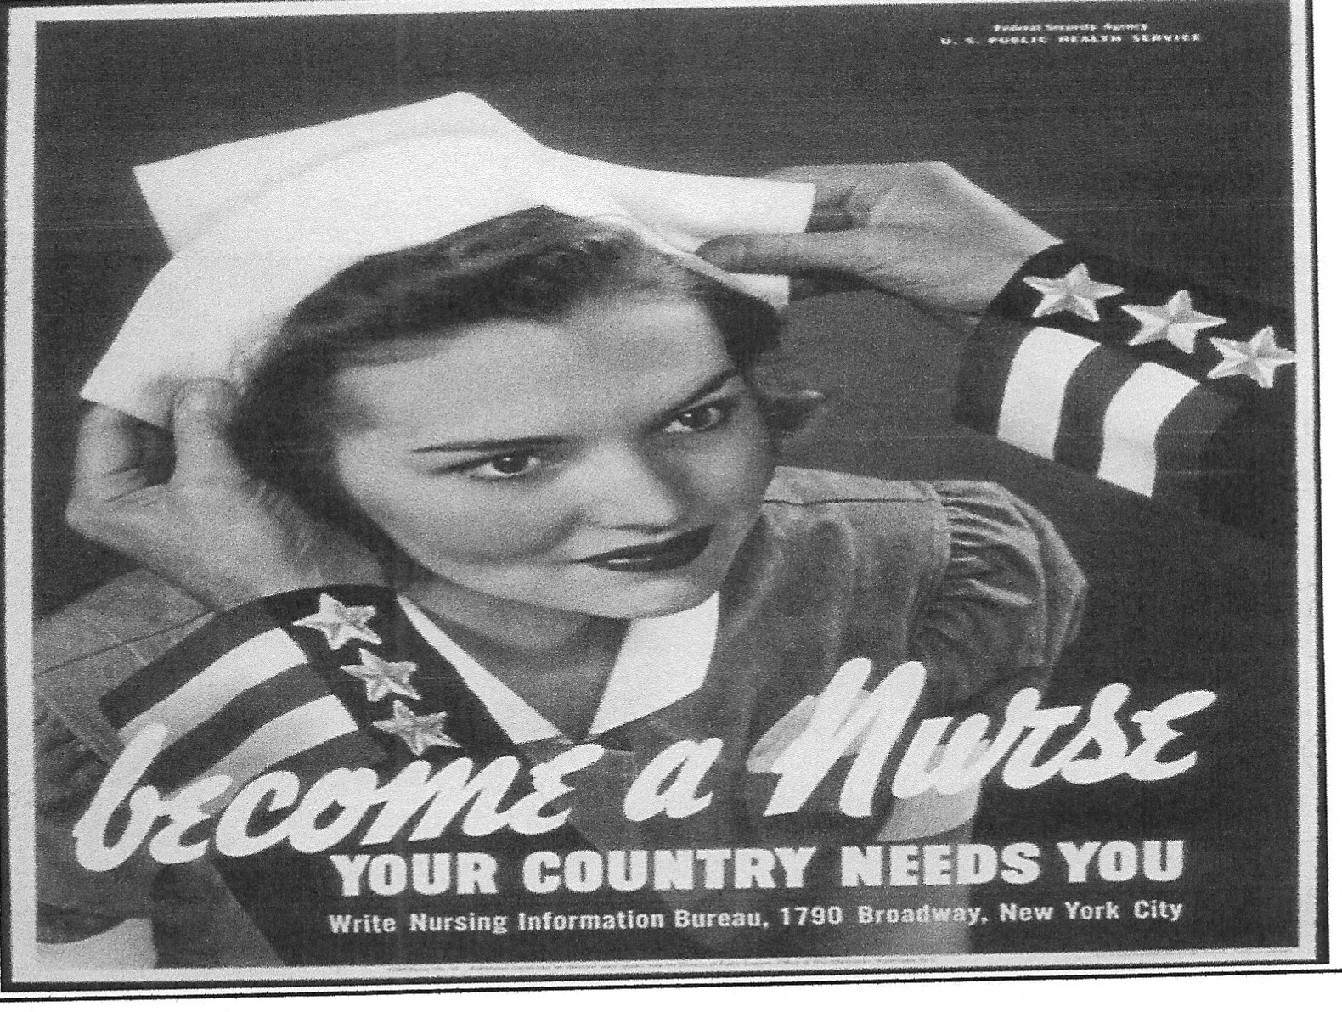
© NADONA 2024

44

Resources
- https://explorehealthcareers.org/get-started-now-youve-got-career-ladder-climb/
- https://online.regiscollege.edu/blog/9-essential-gualities-nurse-leadership/
- https://www.americannursetoday.com/nine-principles-of-successful-nursing­ leadership/
- http://nursing.advanceweb.com/effective-nursing-leadership/
- http://soe.syr.edu/academic/counseling and human services/modules/Preparing for Supervision/definition and components of supervision.aspx
- /https://aboutleaders.com/management-and-supervision-vs- leadership/#gs.QZwrQNSg
- http://www.businessdictionary.com/definition/empowerment.html
- https://www.windsor-group.eom.au/our news/what-is-meant-by-empowerment/
- https://www.ncsbn.org/1625.htm

© NADONA 2024
45

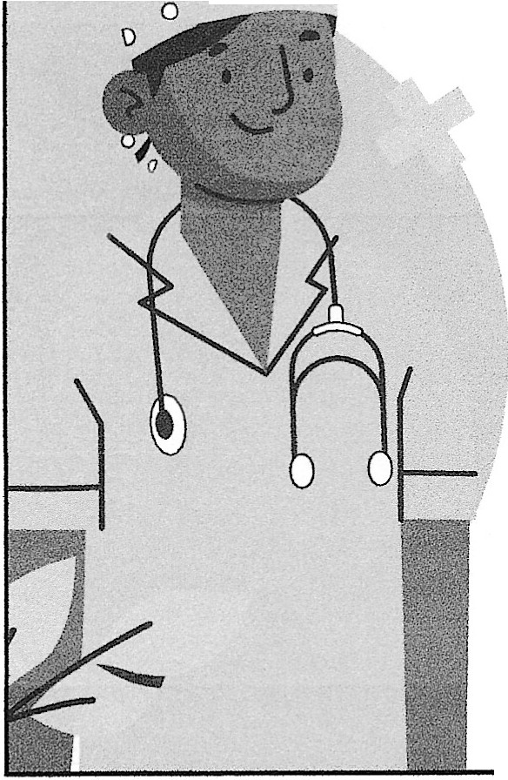
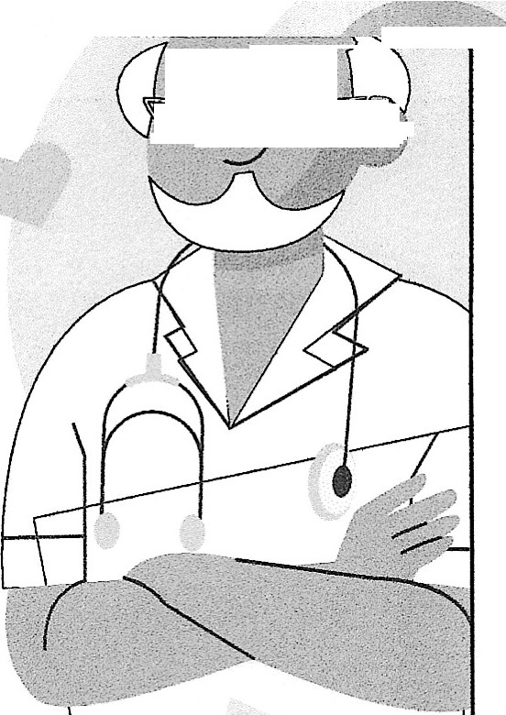
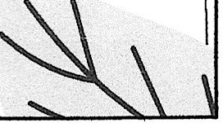
\

r-. -· _Q <>=
---9

D I"0 0 (l

Thanks

·a :' ·•.• .

0
Cindy Fronning cindy@nadona.org 651-324-8415

CREDITS: This presentation template was created by Slidesgo, and includes icons by Flaticon, and infographics & images by Freepik

Please keep this slide for attribution
', .. -.._,
. . -. .'/,, :)"

46

